Quang Tran

CIS 310-02

Prof. Guan

10/11/2017

Assignment 5

1.)

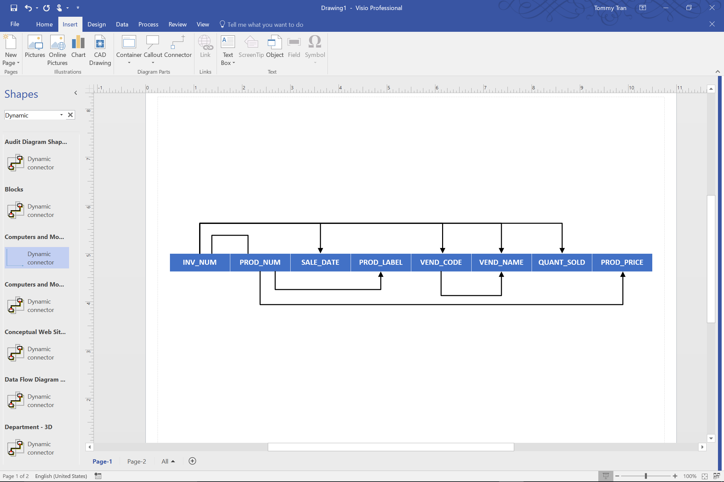

2.) The table is in 1NF because each row is uniquely identified.

3.) The table is not in 2NF because there are existing partial dependencies, where determinates are part of the primary key.

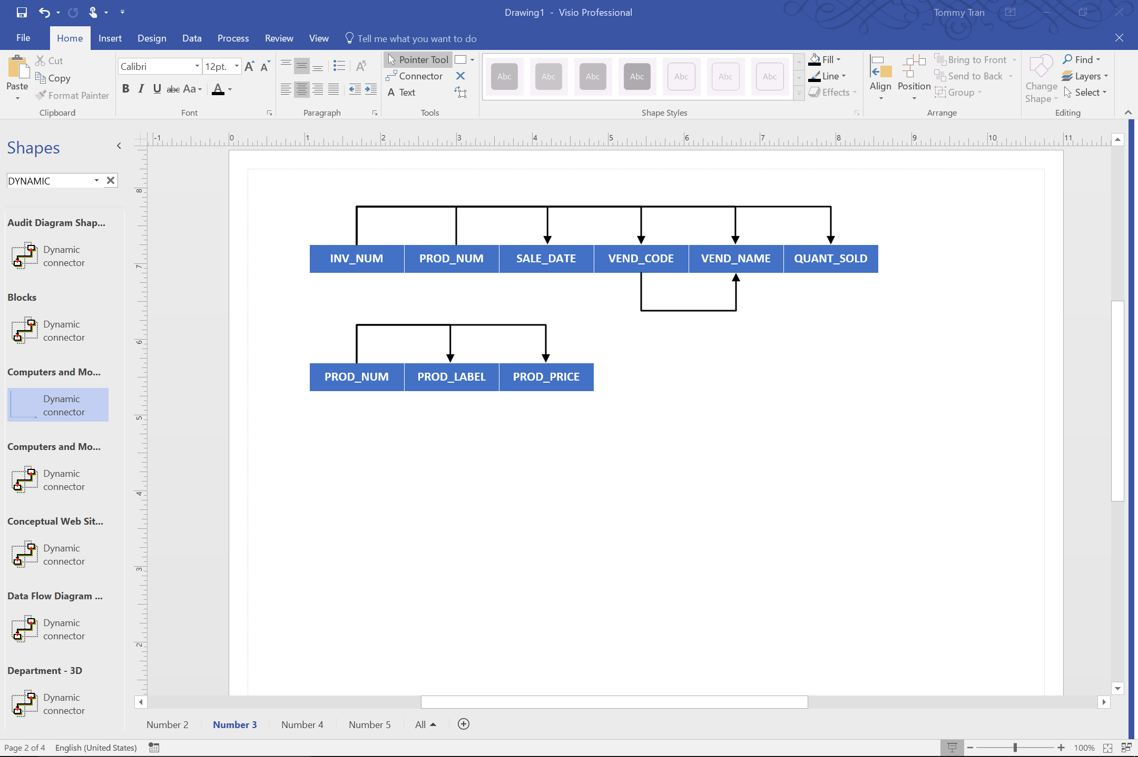

4.) The table is not in 3NF, because there are existing transitive dependencies, where non-primary keys determine other non-primary keys.

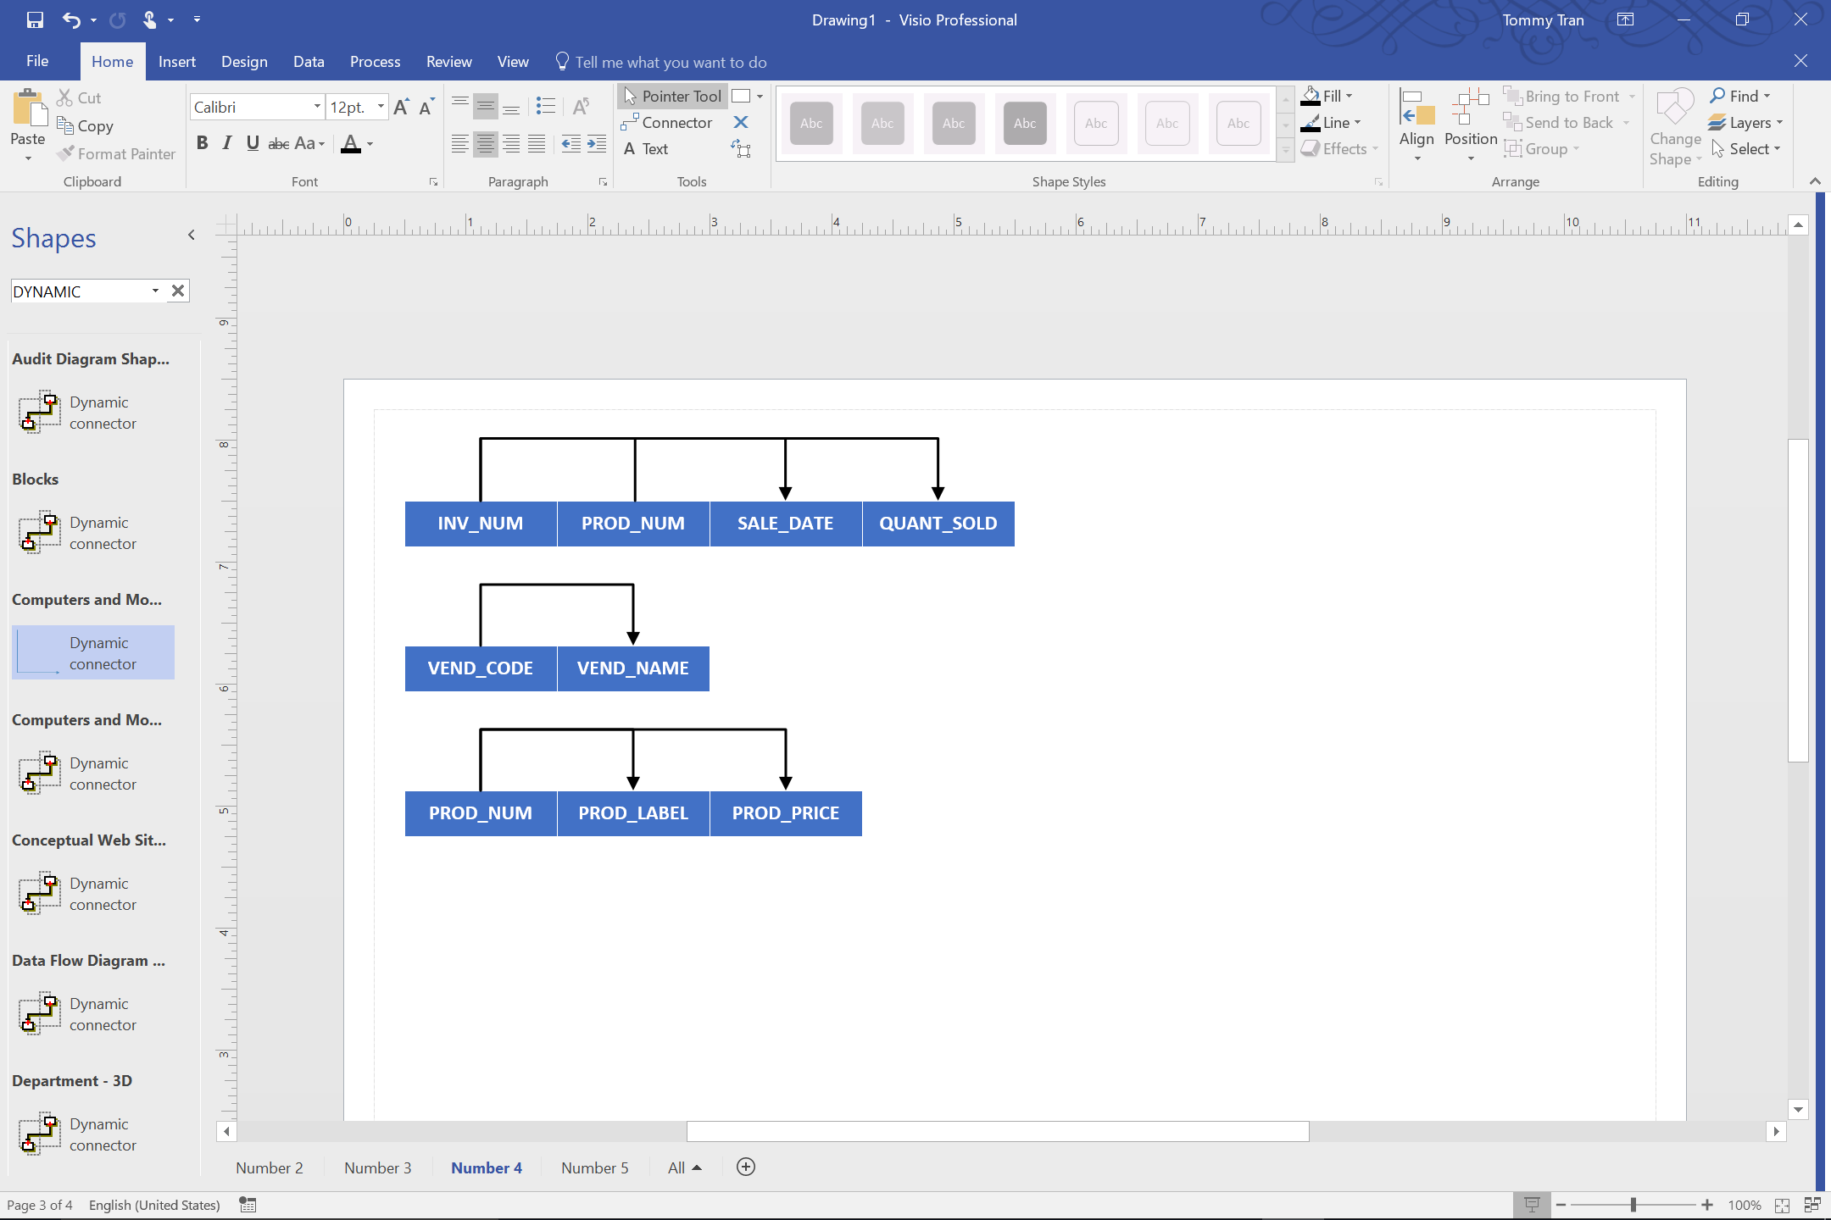

5.)

